Contribution Title – Not More than 20 Words Times New Roman Font Size 12, Bold, Centred, Capitalized Each Word

First Author¹, Second Author², Third Author³ (Times New Roman, Capitalized Each Word, Font Size 12, Centered)
¹²³Affiliation (e.g. STKIP Pasundan) Times New Roman font size 10 in italics, centred,Country
Email: Author(s) email (Times New Roman, font size 10, centred, single spacing)

First Received: (the date you send the manuscript) Final Proof Received: (the date you send the final version )

ABSTRACT
The abstract should be written in one paragraph, and should not be more than 250 words. Times New Roman, font size 12, single spacing. Follow the following pattern: General statement about the importance of the topic, gap in literature or discrepancies between theories and practices, purpose of study, method, main findings, and conclusion.

Keywords: First Keyword, Second Keyword, Third Keyword, Fourth Keyword Times New Roman, 12, italics, single spacing (no more than two lines)

MAIN HEADINGS - FONT SIZE 12, BOLD, CAPITALISED
Subheadings - Font size 12, Bold, Capitalized Each Word
Subheadings - Font size 12, Bold, Italic, Sentence case

INTRODUCTION
The article should contain between 4,000 to 8,000 words, single-spaced, Times New Roman, font size 12, excluding references and appendices. Please note that submissions to our journal should not exceed 25% similarity with existing sources. We uphold strict standards of originality and academic integrity in all submitted manuscripts. Any submissions found which have a similarity percentage higher than 25% will not be considered for publication. Use no indent for the first paragraph and do not leave a space between paragraphs.
The following paragraphs, however, are indented with the first line 0.75cm.

A review of the literature can be merged into the Introduction.
Subheading

METHOD
Respondents
Subheading

Instruments

Procedures

Data Analysis
etc.

FINDINGS AND DISCUSSION
Subheading 1 (research question 1)
Subheading

Subheading 2 (research question 2)
Subheading

Subheading 3 (research question 3)
Subheading

Etc.

CONCLUSION

REFERENCES

APPENDIX
Add here if any.

FIGURE AND TABLES
Place titles of Figures after the figures and Tables preceding them using Times New Roman font size 10 for the title.

Table 1. Number of subthemes published in Journal

Subtheme | No | The font of the table is Times New Roman (font size 9)
English Education | 17 | The font of the table is Times New Roman (font size 9)
Linguistics | 8 | The font of the table is Times New Roman (font size 9)
English Literature | 13 | The font of the table is Times New Roman (font size 9)
Total | 38 | The font of the table is Times New Roman (font size 9)

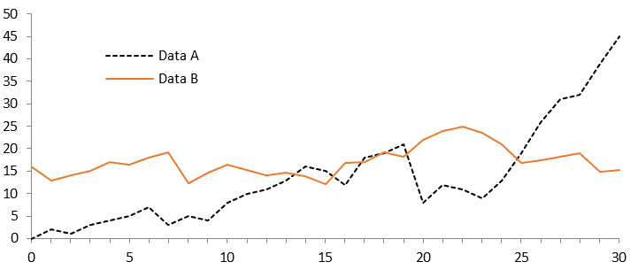
Figure 1. Number of subthemes published in Journal
A figure caption is always placed below the illustration. Short captions are centered, while long ones are justified.

CITATION:
Use Mendeley is recommended (APA for in-text citations and the reference list (Angeli et al, 2010). For in-text citations, use the author’s name and year (Author, 2020), and if there are direct quotes, then provide the page number (Author, 2022, p. 24). If you are citing more than one reference, put them in alphabetical order (Alpha, 2008; Beta, 2009). For a reference with up to five authors, use all the names in the first instance (Author1, Author2, Author3, Author4 & Author5, 2007), and then use the first author et al. subsequently (Author1 et al., 2007). Do not use footnotes.)

